**Lab 6: Using HDFS Access Control Lists**

Objective: To configure and use HDFS access control lists (ACLs)

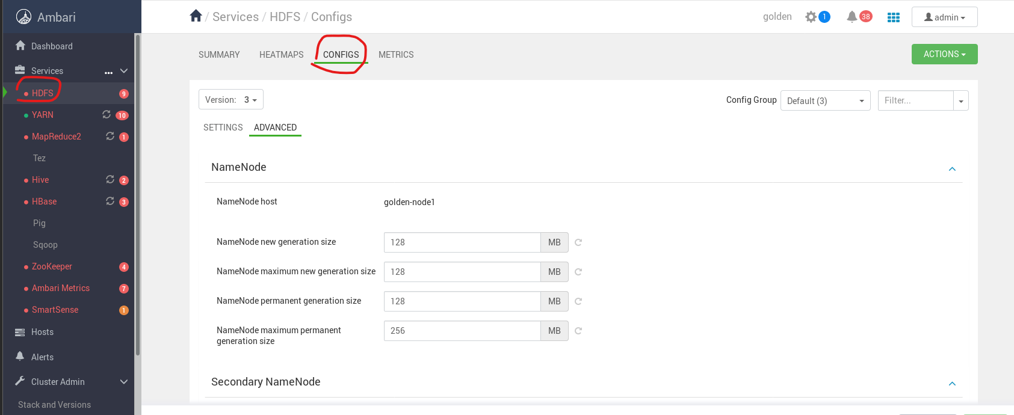

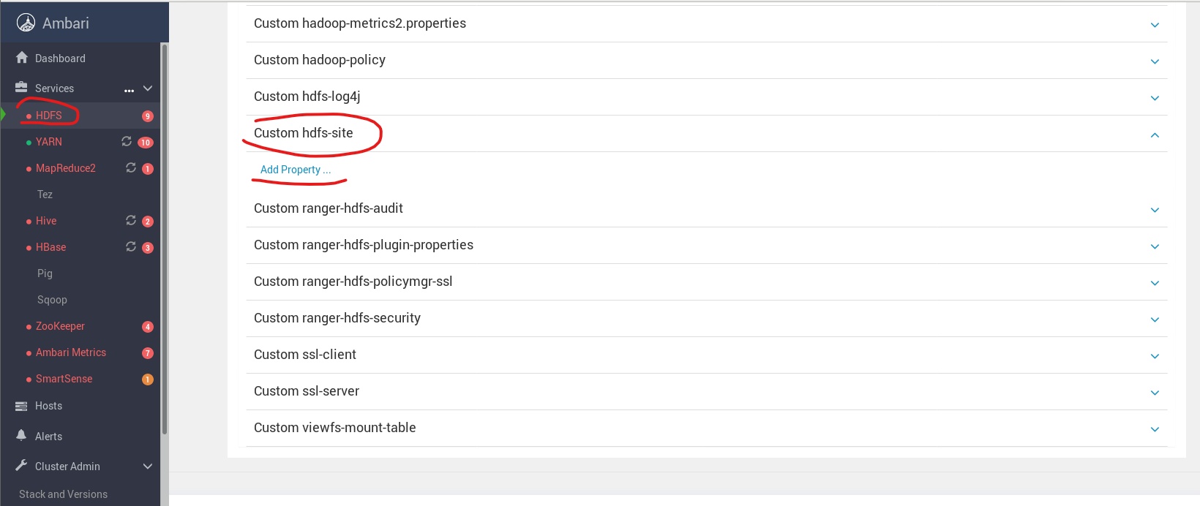

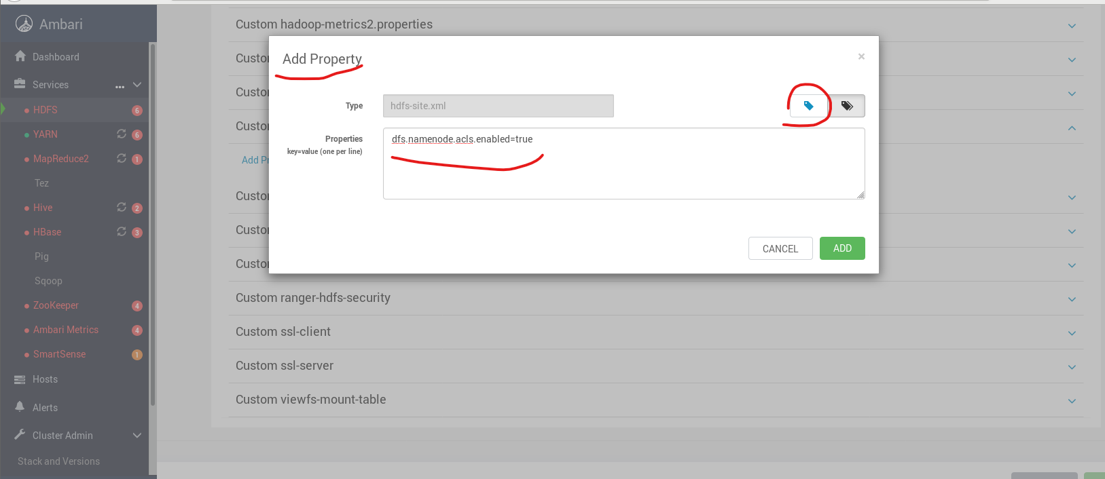

[root@golden-node1 ~]# su - hdfs

[hdfs@golden-node1 ~]$ hdfs dfs -mkdir /acltests

[hdfs@golden-node1 ~]$ hdfs dfs –ls /

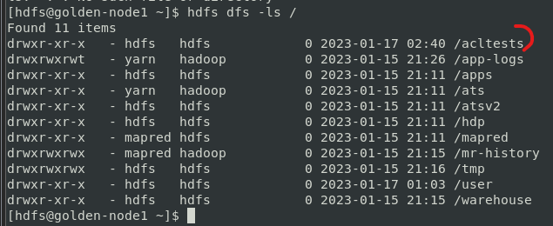

[hdfs@golden-node1 ~]$ hdfs dfs -put /etc/passwd /acltests

[hdfs@golden-node1 ~]$ hdfs dfs -ls /acltests

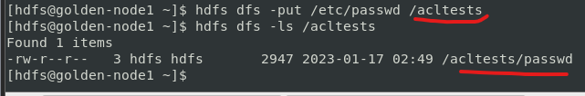

[hdfs@golden-node1 ~]$ hdfs dfs -chmod 640 /acltests/passwd

[hdfs@golden-node1 ~]$ hdfs dfs -ls /acltests

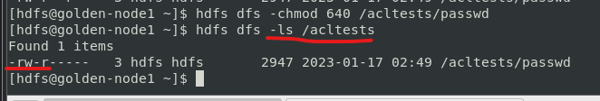

[hdfs@golden-node1 ~]$ exit

[root@golden-node1 ~]# hdfs dfs -cat /acltests/passwd

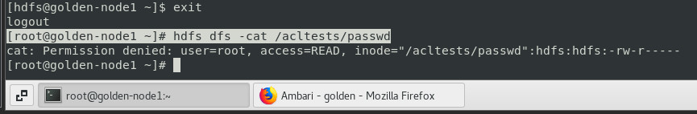

[hdfs@golden-node1 ~]$ hdfs dfs -getfacl /acltests/passwd

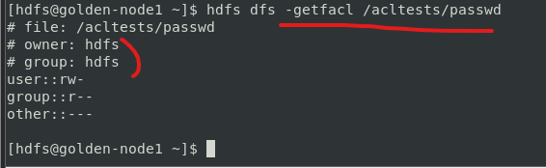

[hdfs@golden-node1 ~]$ hdfs dfs -ls /acltests

[hdfs@golden-node1 ~]$ hdfs dfs -setfacl -m user:root:r-- /acltests/passwd

[hdfs@golden-node1 ~]$ hdfs dfs -getfacl /acltests/passwd

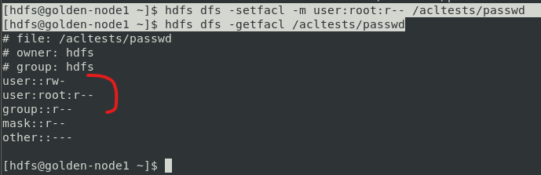

[hdfs@golden-node1 ~]$ exit

[root@golden-node1 ~]# hdfs dfs -cat /acltests/passwd

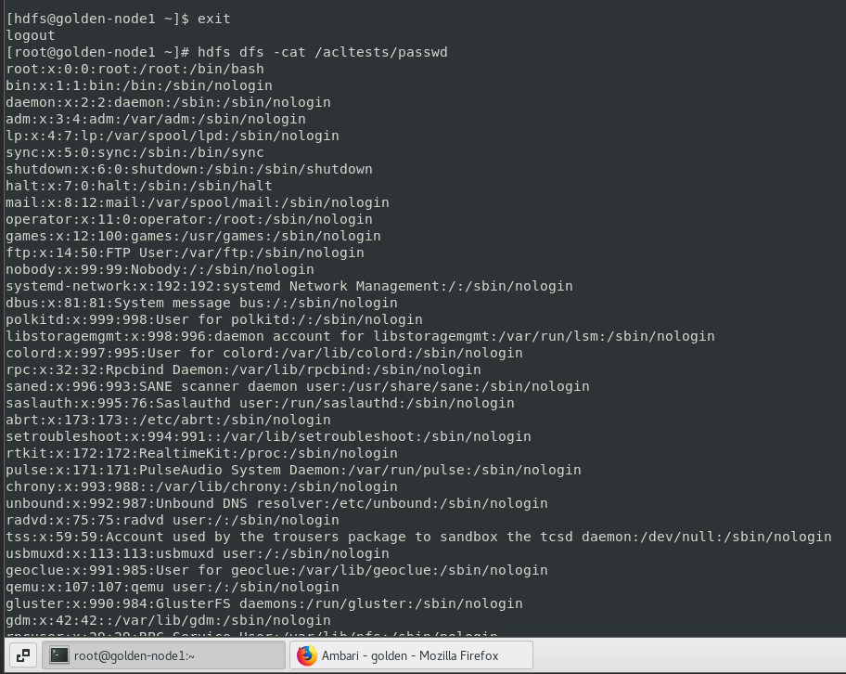

[hdfs@golden-node1 ~]$ hdfs dfs -setfacl -m group:hcat:rw- /acltests/passwd

[hdfs@golden-node1 ~]$ hdfs dfs -getfacl /acltests/passwd

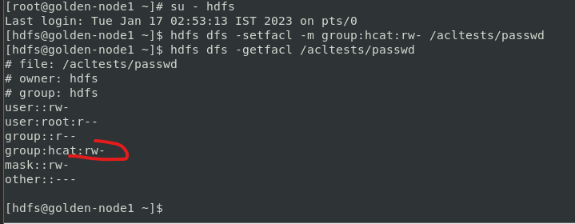

[hdfs@golden-node1 ~]$ hdfs dfs -setfacl -x group:hcat /acltests/passwd

[hdfs@golden-node1 ~]$ hdfs dfs -getfacl /acltests/passwd

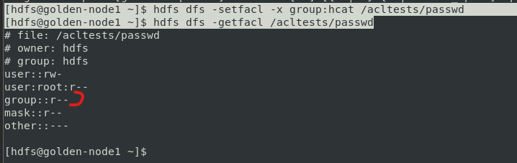

[hdfs@golden-node1 ~]$ hdfs dfs -setfacl --set user::rw-,group::rw-,other::---,user:admin:rw-,group:hcat:rw- /acltests/passwd

[hdfs@golden-node1 ~]$ hdfs dfs -getfacl /acltests/passwd

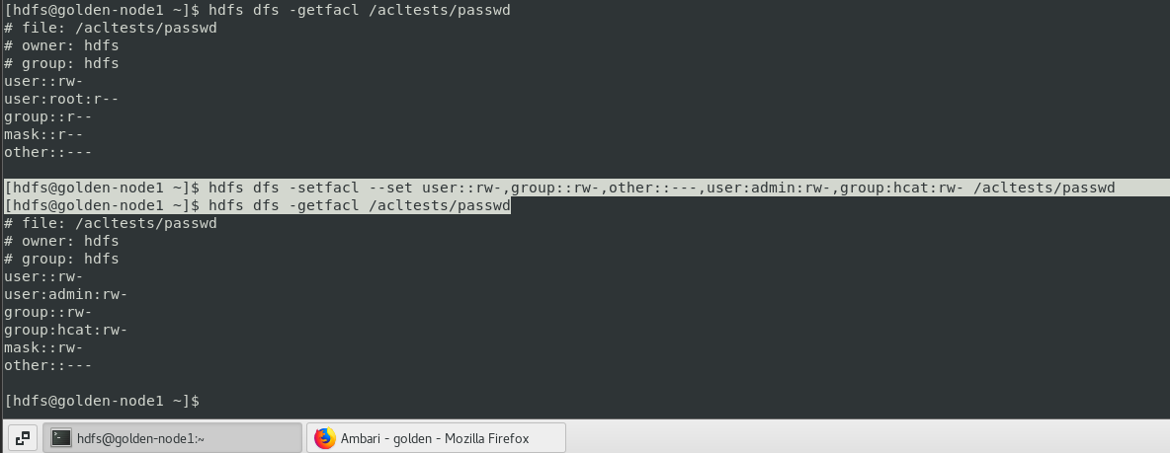

[hdfs@golden-node1 ~]$ hdfs dfs -setfacl -b /acltests/passwd

[hdfs@golden-node1 ~]$ hdfs dfs -getfacl /acltests/passwd

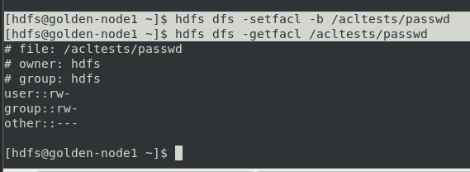

[hdfs@golden-node1 ~]$ hdfs dfs -put /etc/passwd /acltests/group

[hdfs@golden-node1 ~]$ hdfs dfs -ls /acltests

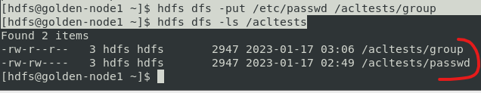

**Managing Directory ACLs**

[hdfs@golden-node1 ~]$ hdfs dfs -getfacl /acltests

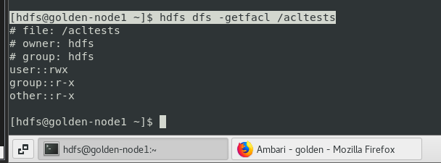

[hdfs@golden-node1 ~]$ hdfs dfs -setfacl -m default:user:root:rw- /acltests

[hdfs@golden-node1 ~]$ hdfs dfs -getfacl /acltests

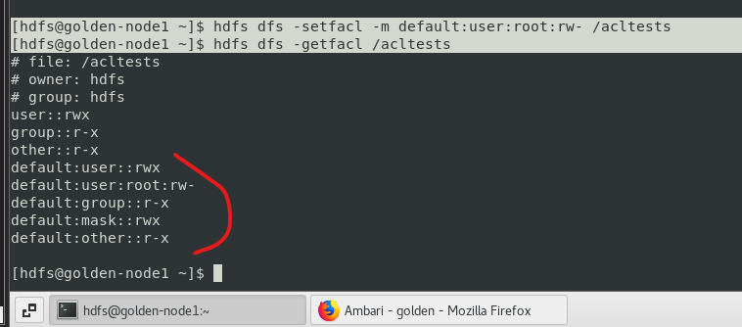

[hdfs@golden-node1 ~]$ hdfs dfs -put /etc/hosts /acltests

[hdfs@golden-node1 ~]$ hdfs dfs -getfacl /acltests/hosts

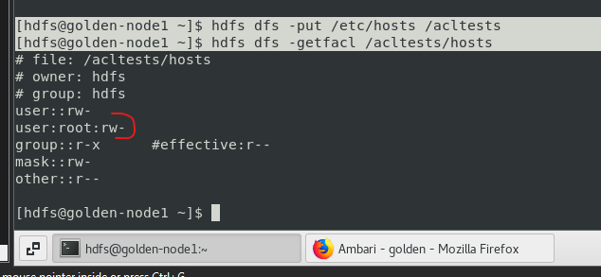

[hdfs@golden-node1 ~]$ hdfs dfs -getfacl /acltests/group

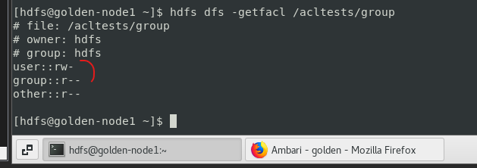

[hdfs@golden-node1 ~]$ exit

[root@golden-node1 ~]# hdfs dfs -cat /acltests/hosts

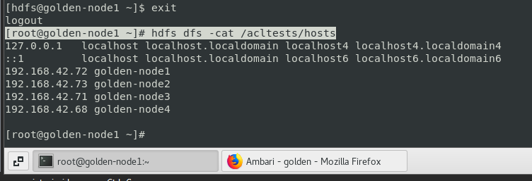

[root@golden-node1 ~]# su - hdfs

[hdfs@golden-node1 ~]$ hdfs dfs -mkdir /acltests/dir1

[hdfs@golden-node1 ~]$ hdfs dfs -ls /acltests

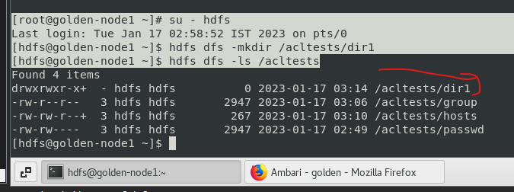

[hdfs@golden-node1 ~]$ hdfs dfs -getfacl /acltests/dir1

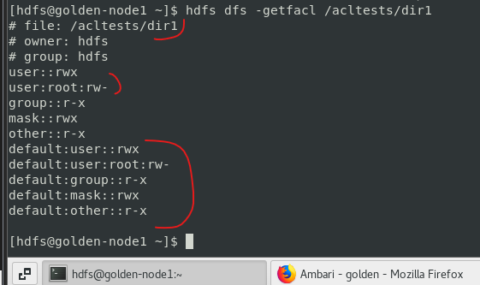

**Managing Access Using Access Mask**

**[hdfs@golden-node1 ~]$ hdfs dfs -setfacl -m mask::--- /acltests/hosts**

**[hdfs@golden-node1 ~]$ hdfs dfs -getfacl /acltests/hosts**

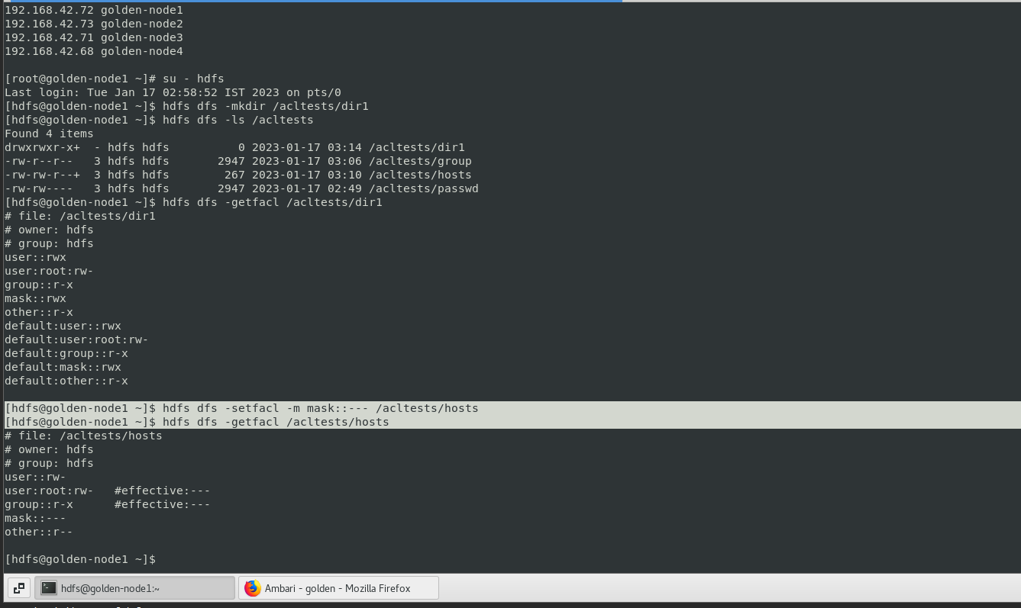

**[hdfs@golden-node1 ~]$ exit**

**logout**

**[root@golden-node1 ~]# hdfs dfs -cat /acltests/hosts**

**cat: Permission denied: user=root, access=READ, inode="/acltests/hosts":hdfs:hdfs:-rw----r--**

**[root@golden-node1 ~]#**

